

**Template: Set SDG Strategy**

**Impact Measurement and Management for Sustainable Development Goals**

Use this template to organize your thinking about your most material SDG Outcomes (a WHAT/WHO combination), the ABC Goal of each outcome, and the associated impact thesis.

|  |  |  |  |  |
| --- | --- | --- | --- | --- |
| WHAT | & | WHO | GOAL | **“ ”**  IMPACT THESIS |
| SDG goal and target |  | Stakeholders that experience change as a result of your activities | The level of impact you are targeting | “If we …….., then we believe  ……….. will happen.” |
|  |  |  |  |  |
|  |  |  |  |  |
|  |  |  |  |  |
|  |  |  |  |  |
|  |  |  |  |  |

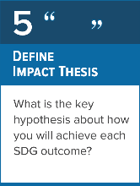



WRITTEN & PRODUCED BY:

BROUGHT TO YOU BY:



© United Nations Development Programme